CHECK LỖI STAFF
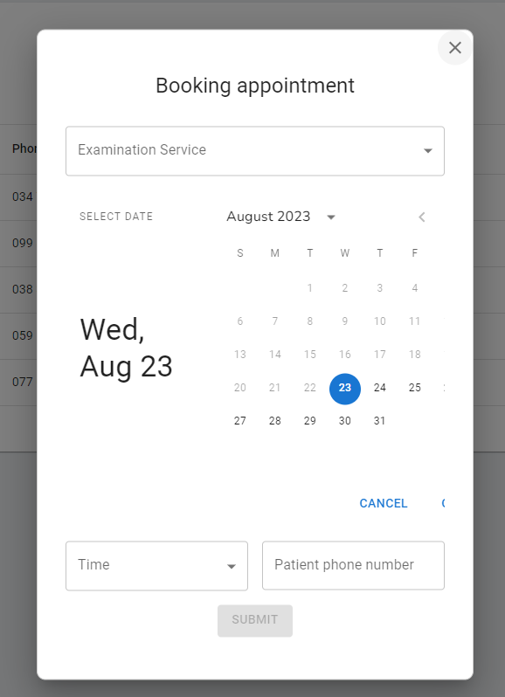

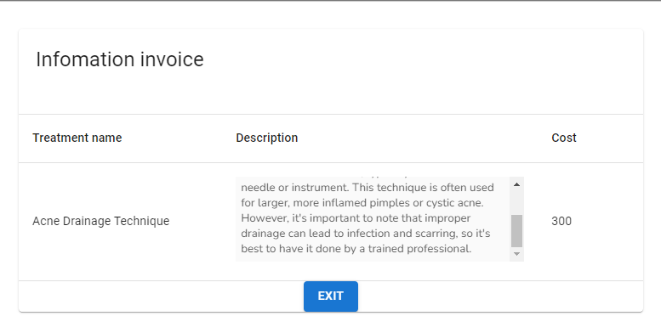

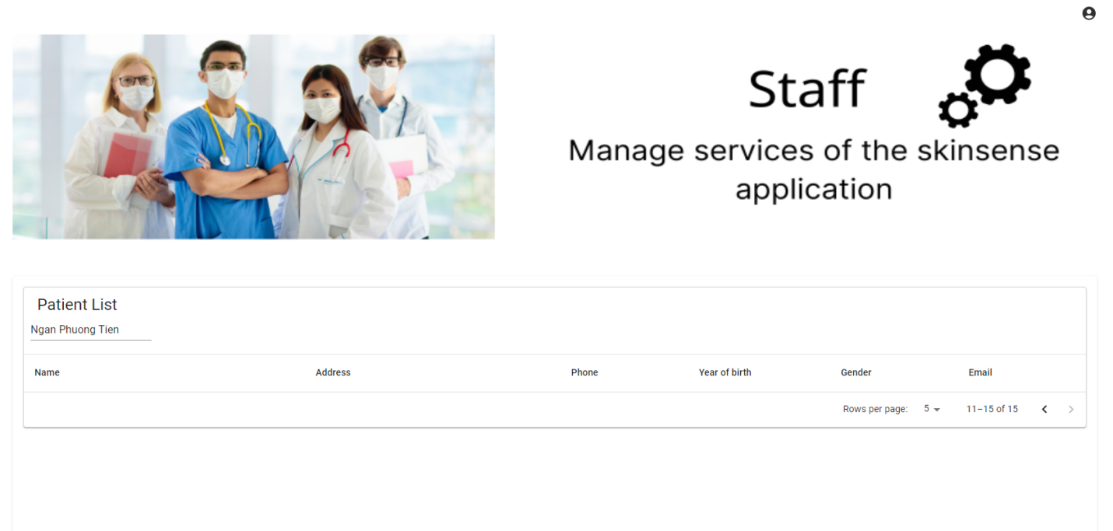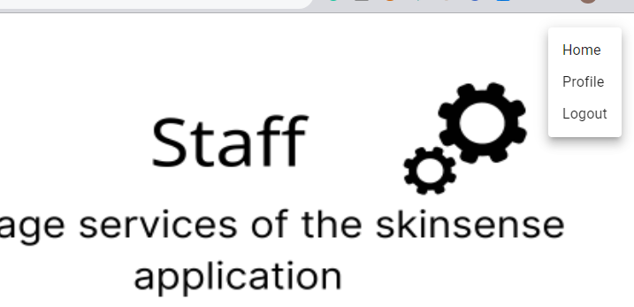

Figure 1. bỏ nút profile
admin
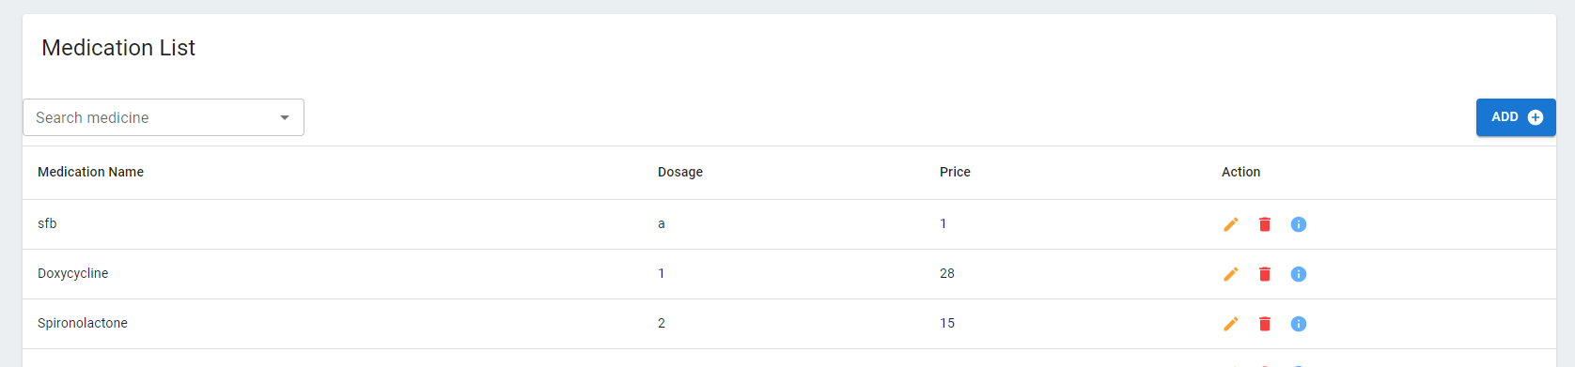
Dosage so deo phai chu
Doi ki hieu thong bao add ko dung dosage vs price

